Customer Shopping Behavior Analysis

1. Project Overview
This project analyzes customer shopping behavior using transactional data from 3,900 purchases across various product categories. The goal is to uncover insights into spending patterns, customer segments, product preferences, and subscription behavior to guide strategic business decisions.

2. Dataset Summary
- Rows: 3,900
- Columns: 18
- Key Features:
- Customer demographics (Age, Gender, Location, Subscription Status)
- Purchase details (Item Purchased, Category, Purchase Amount, Season, Size, Color)
-Shopping behavior (Discount Applied, Promo Code Used, Previous Purchases, Frequency of
Purchases, Review Rating, Shipping Type)
- Missing Data: 37 values in Review Rating column

3. Exploratory Data Analysis using python
We began with data preparation and cleaning in python:
- Data Loading: imported the dataset using pandas

- Initial Exploration: Used df.info to check structure and describe for summary statistics.

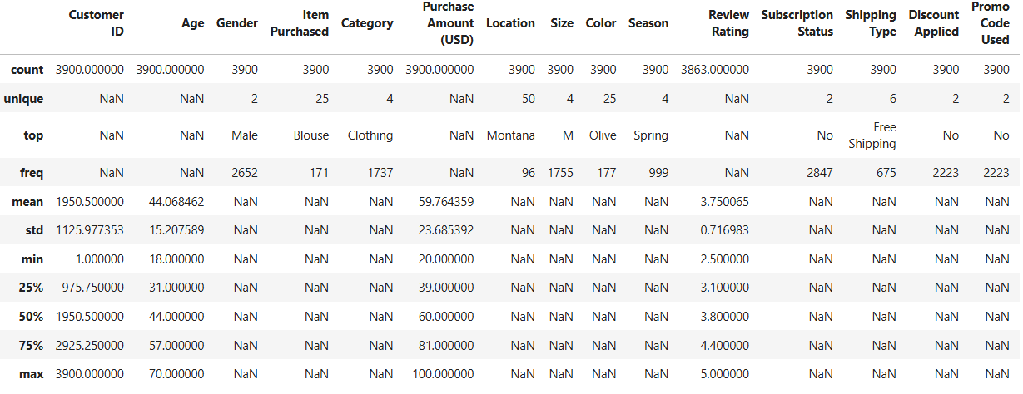

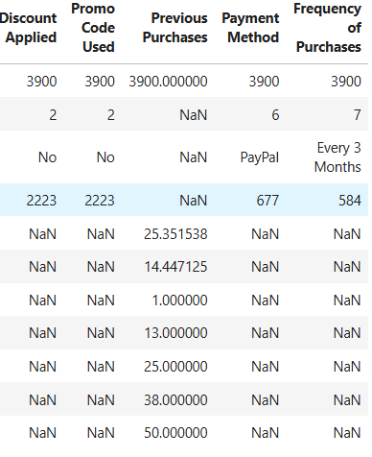
- Missing Data Handling: Checked for null values and imputed missing values in the Review Rating column using the median rating of each product category.

- Column Standardization: Renamed columns to snake case for better readability and documentation.

- Feature Engineering:

- Created Age column by binning customer ages.

- Created purchase frequency days column from purchase data.

- Data Consistency Check: Verified is Discount applied and promo code used were redundant; dropped promo code used.
- Database Integration: Connected Python script to MySQL and loaded the cleaned Data Frame into the database for SQL analysis.

4. Data Analysis using SQL

We performed structured analysis in MySQL to answer key business questions:
- Revenue by Gender – Compared total revenue generated by male vs. female customers.

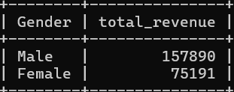

- High-Spending Discount Users – Identified customers who used discount but still spent above the average Purchase Amount.

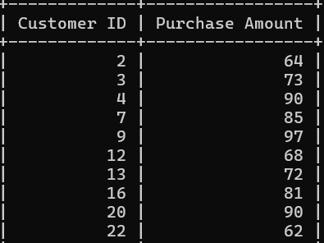
Total rows: 839

- Top 5 Product by Rating – Found Product with the highest average review ratings.

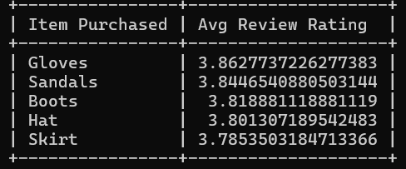

- Shipping Type Comparison – Compared average purchase amounts between Standard and Express shipping.

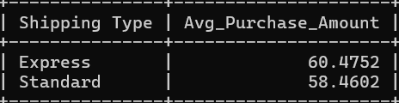
- Subscribers vs Non-Subscribers- Compared average spend and total revenue across subscription status.
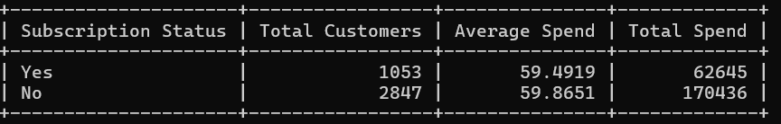
- Discount-Dependent Product – identified 5 product with the highest percentage of discounted purchases.
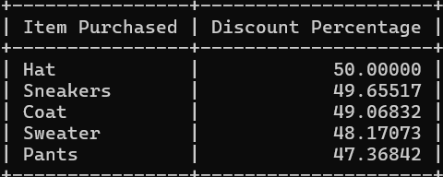
- Customer Segmentation- Classified customers into New, Returning, and Loyal segments based on purchase history.

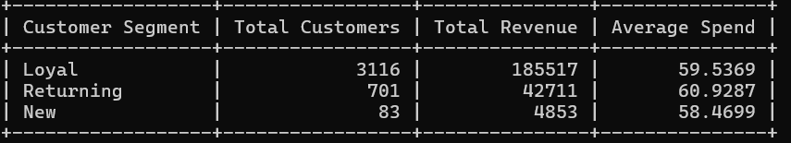
- Top 3 Product Per Category – Listed the most purchased products within each category.

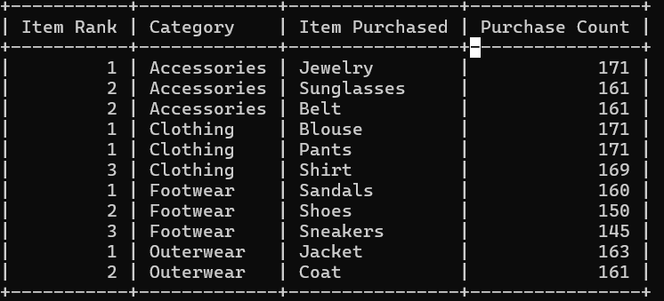

- Repeat Buyers & Subscription – Checked whether with >5 purchase Are more likely to subscribe.

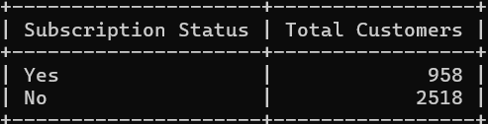

- Revenue by Age Group – Calculated total revenue contribution of each age group.
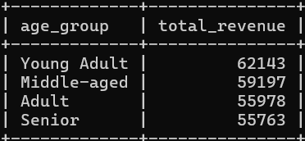

5. Dashboard in Power BI
Finally, we built an interactive dashboard in power BI to present insights visually.

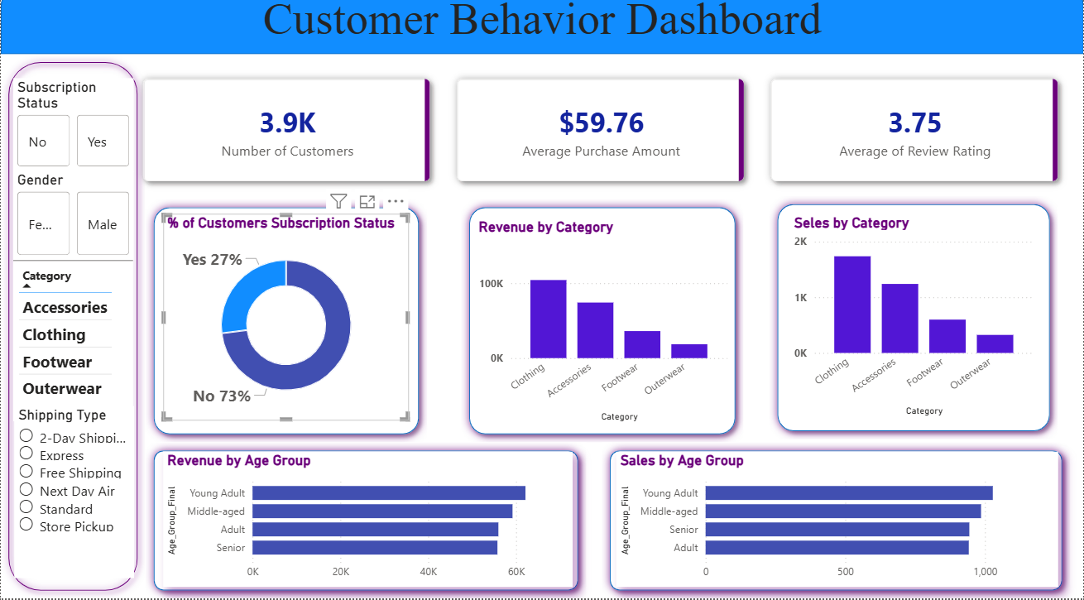

6. business Recommendations-
- Boost Subscription- Promote exclusive benefits for subscribers.
- Customers Loyalty Programs- Reward repeat buyers to move them into “Loyal” segment.

- Review Discount Policy – Balance sales boosts with margin control.

- Product Positioning – Highlight top-rated and best-selling products in campaigns.

- Targeted Marketing – Focus efforts on high-revenue age group and express-shipping users.

